# 3-D modeling of Kansas State University Veterinary Medicine Library

## 

## Yuto Wada

## Kansas State University

## CIS 536: Computer Graphics

## June, 25, 2023

## 

## 

## Overview

My Project was over creating 3-D modeling/Replica of Vet Med Library. The project will focus on the realism of the physical aspect of the library, mainly focusing on the texture of things like furniture, walls, and the floor. I took pictures of texture of walls, floors and some furniture and used those textures in the modeling to make the modeling more realistic. Some of the furniture used prefabs that I found on the unity assets store to save me time with designing furniture.

## Background

In order to make the 3-D modeling realistic, I downloaded a floor of Trotter hall 4th floor to replicate accurate floor sizing and layout. To make the walls and floor layout easier, I used ProBuilder, which helped me with making accurate geometric shapes. Probuilder required me to look into tutorials to familialize myself with the tool which took about 3-4 hours of tutorial to accomplish. I also reseasched into implementing texture using pictures that I took inside the library. Along with texture, I looked into making the furniture look as realistic as possible. From research, I found that using the Unity Assets store was the best option, as it helped me save time.

## Methodology

First step I took was to obtain the floor plan of the Trotter Hall 4th floor in order to accurately scale the walls and rooms that are located in the library and build walls for the rooms and the library itself. I obtained the floor plan through the K state Website. For this step, I used the tool ProBuilder in order to accurately represent the geometric shapes for walls and floors. I used a tutorial video from YouTube to familalize myself with ProBuilder before I got started with the project.

Second step was to take pictures and videos of the library for reference and texture use. This step took some time as Vet Med library is in use throughout the entire day except at late night. Also, this step required me to take pictures in different lighting conditions in order to get the best picture for texture use. Pictures were also used to get a good grasp about what materials was used for parts of the library.

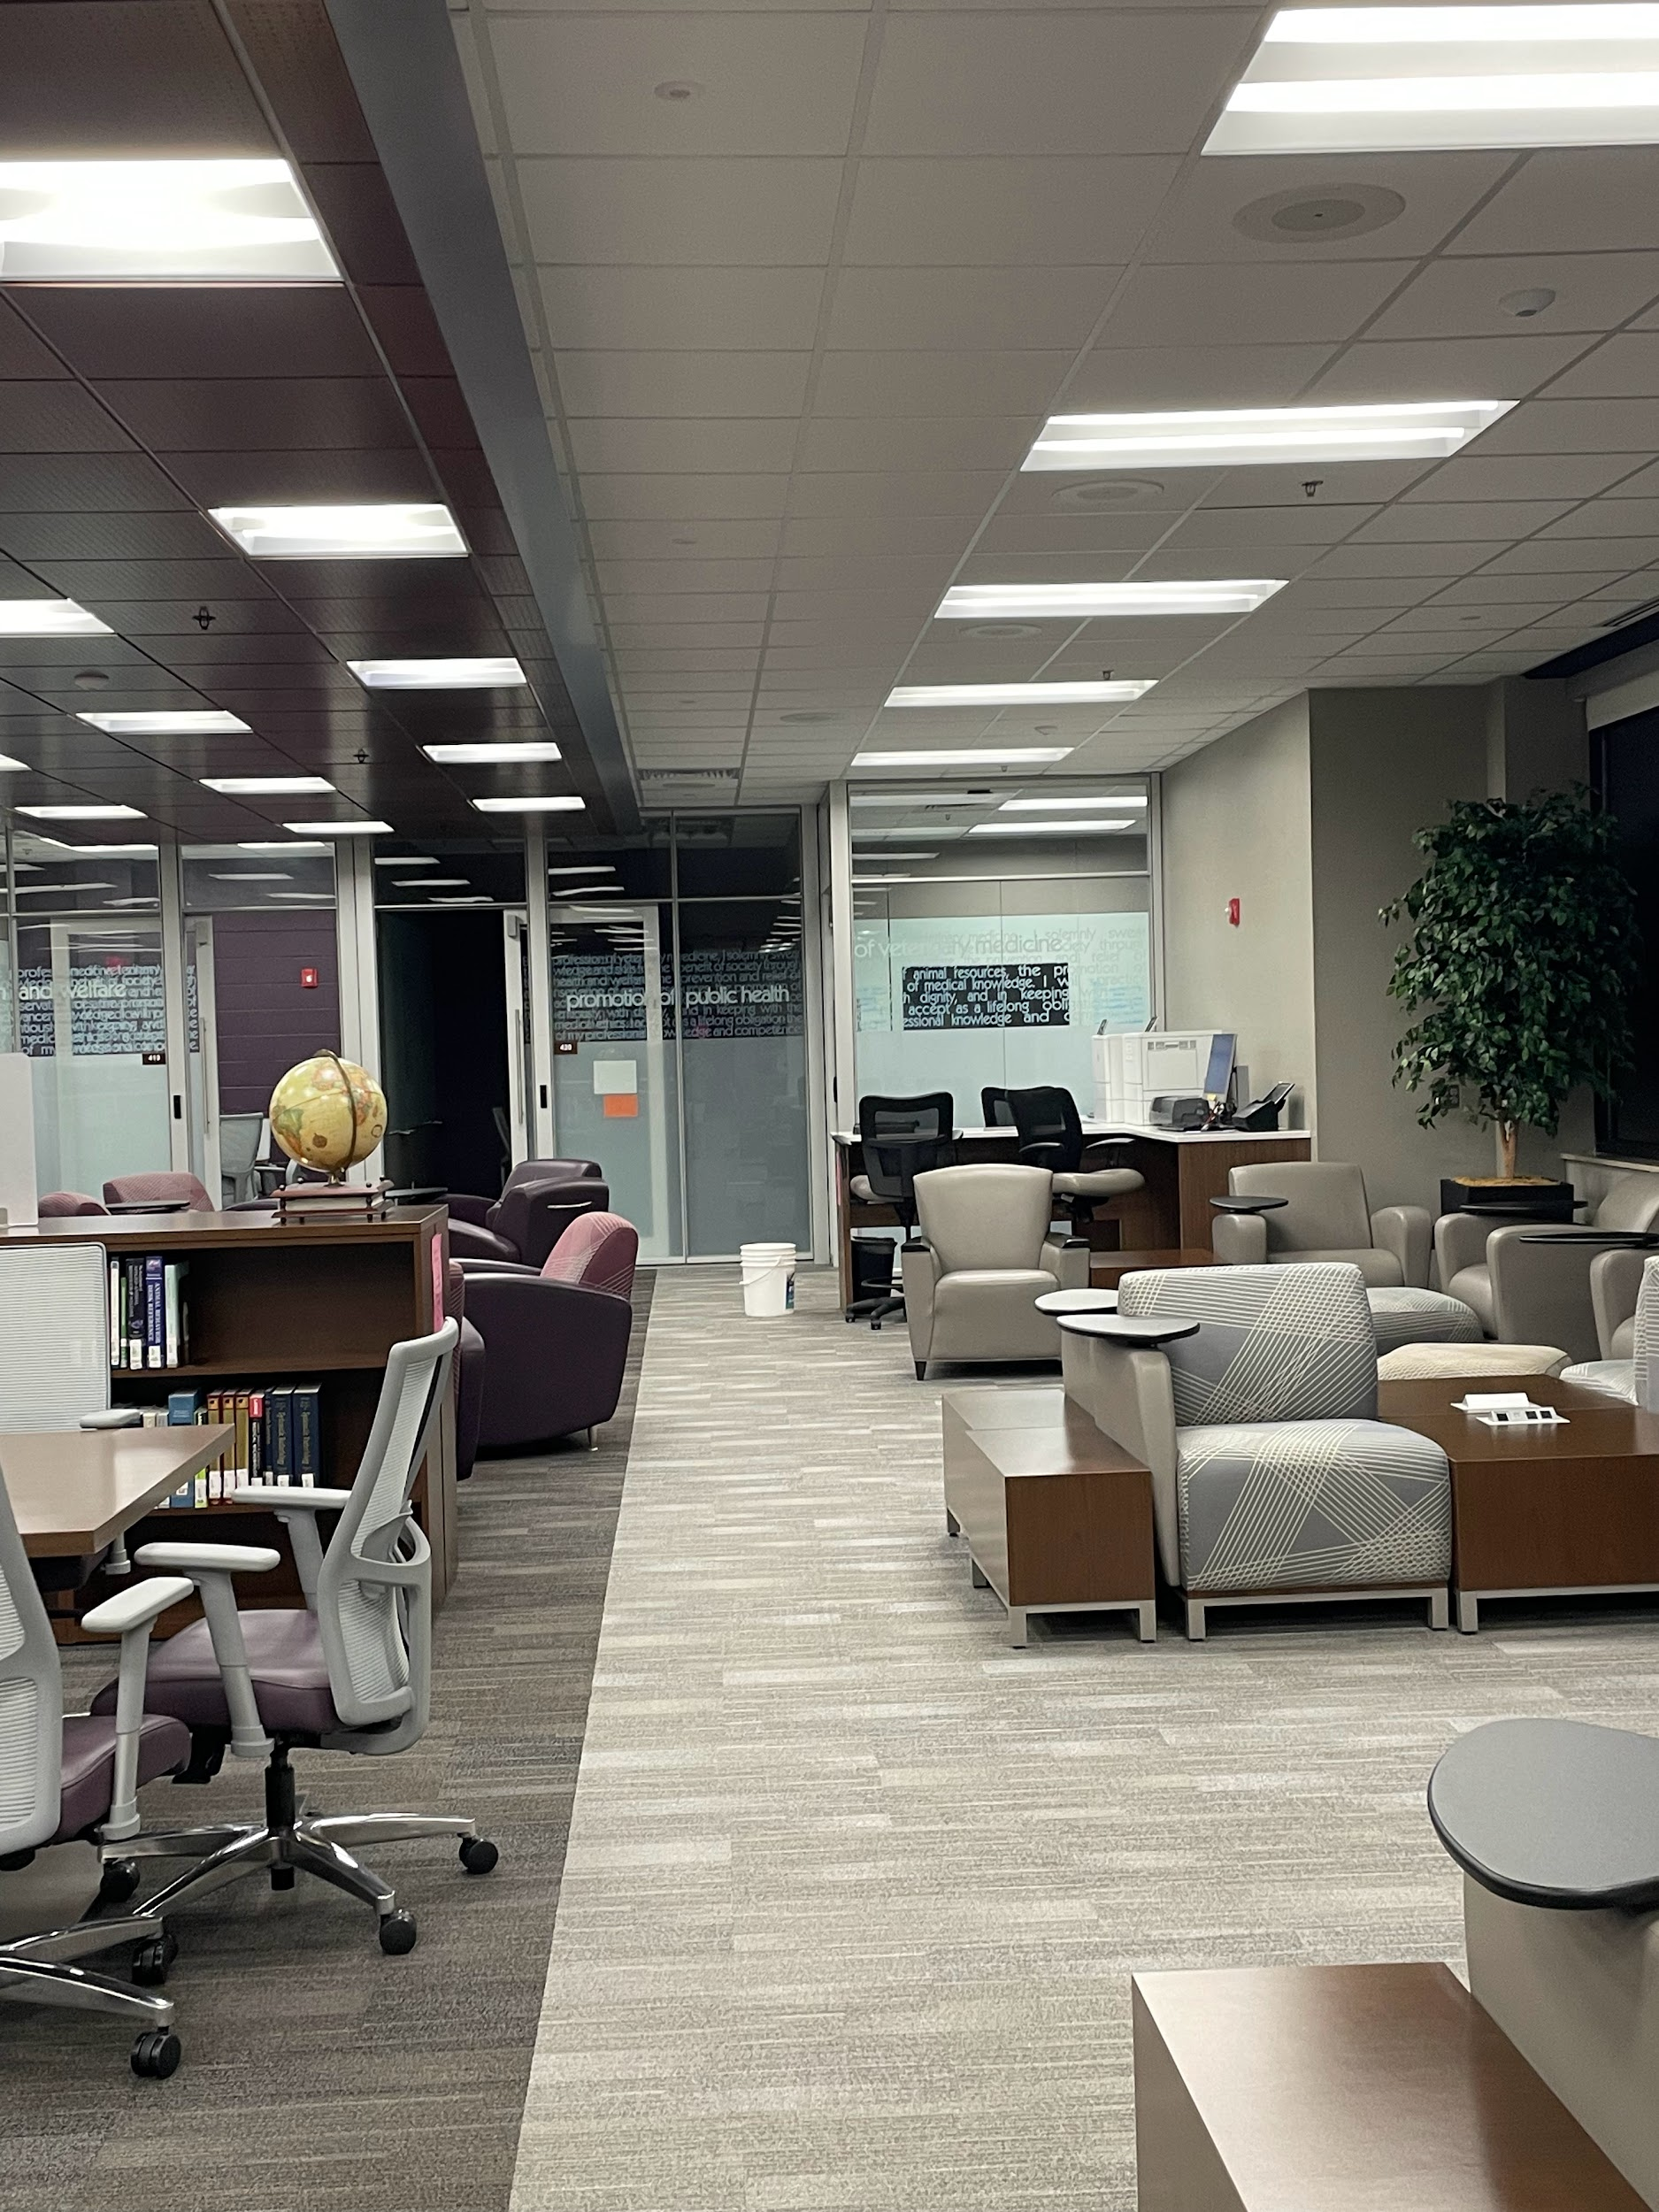

Figure 1. Main Lobby Picture

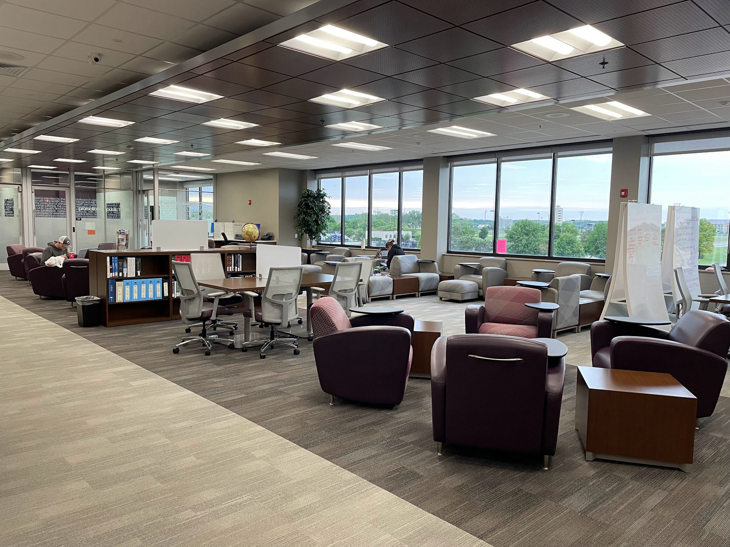

Figure 2. Main Lobby Different angle

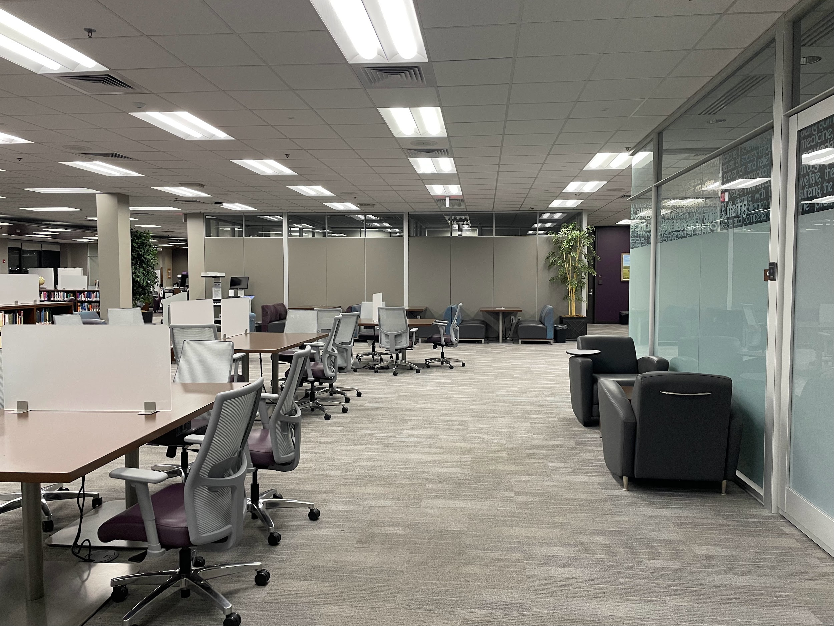

Figure 3. Back Lobby Picture

The third step I took was to edit the texture picture that I took in order to get rid of some shadows and make it usable in the unity texture. This step required some research, as I did not have any experience with photo editing for unity. I followed the tutorial and used GIMP, which is a free image manipulation program in order to get rid of some of the shadow that was present in the texture. I used this method for the carpet of the vet med. Figure 4 is the unedited version of the carpet texture before I used GIMP and Figure 5 is the edited version of the carpet after I used GIMP.

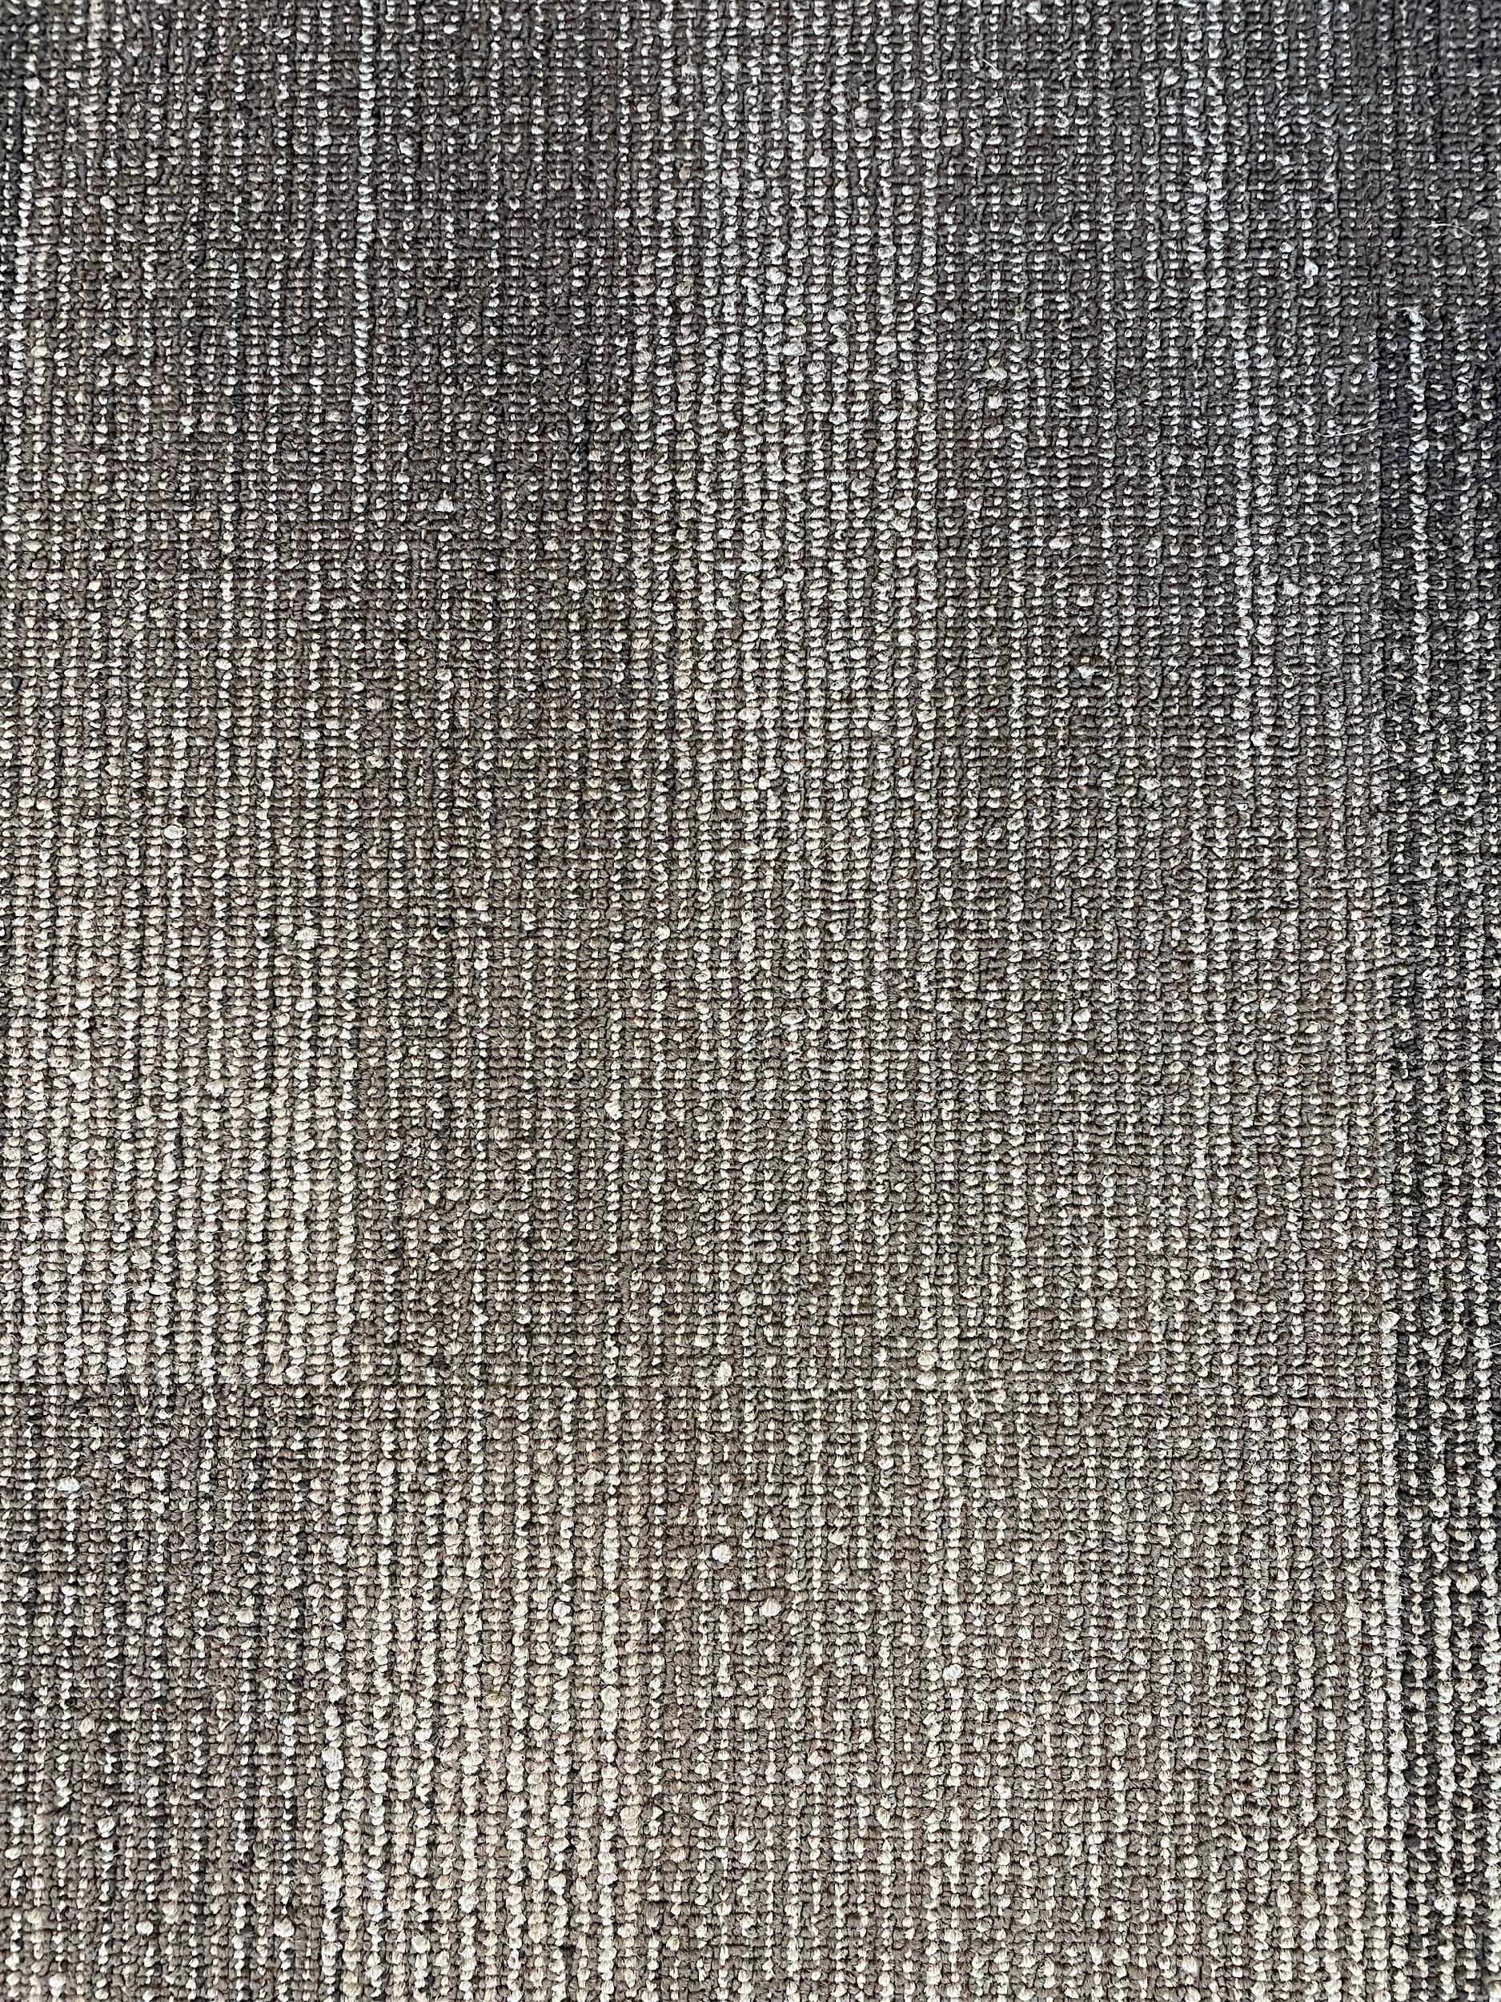

Figure 4. Unedited version of the carpet texture.

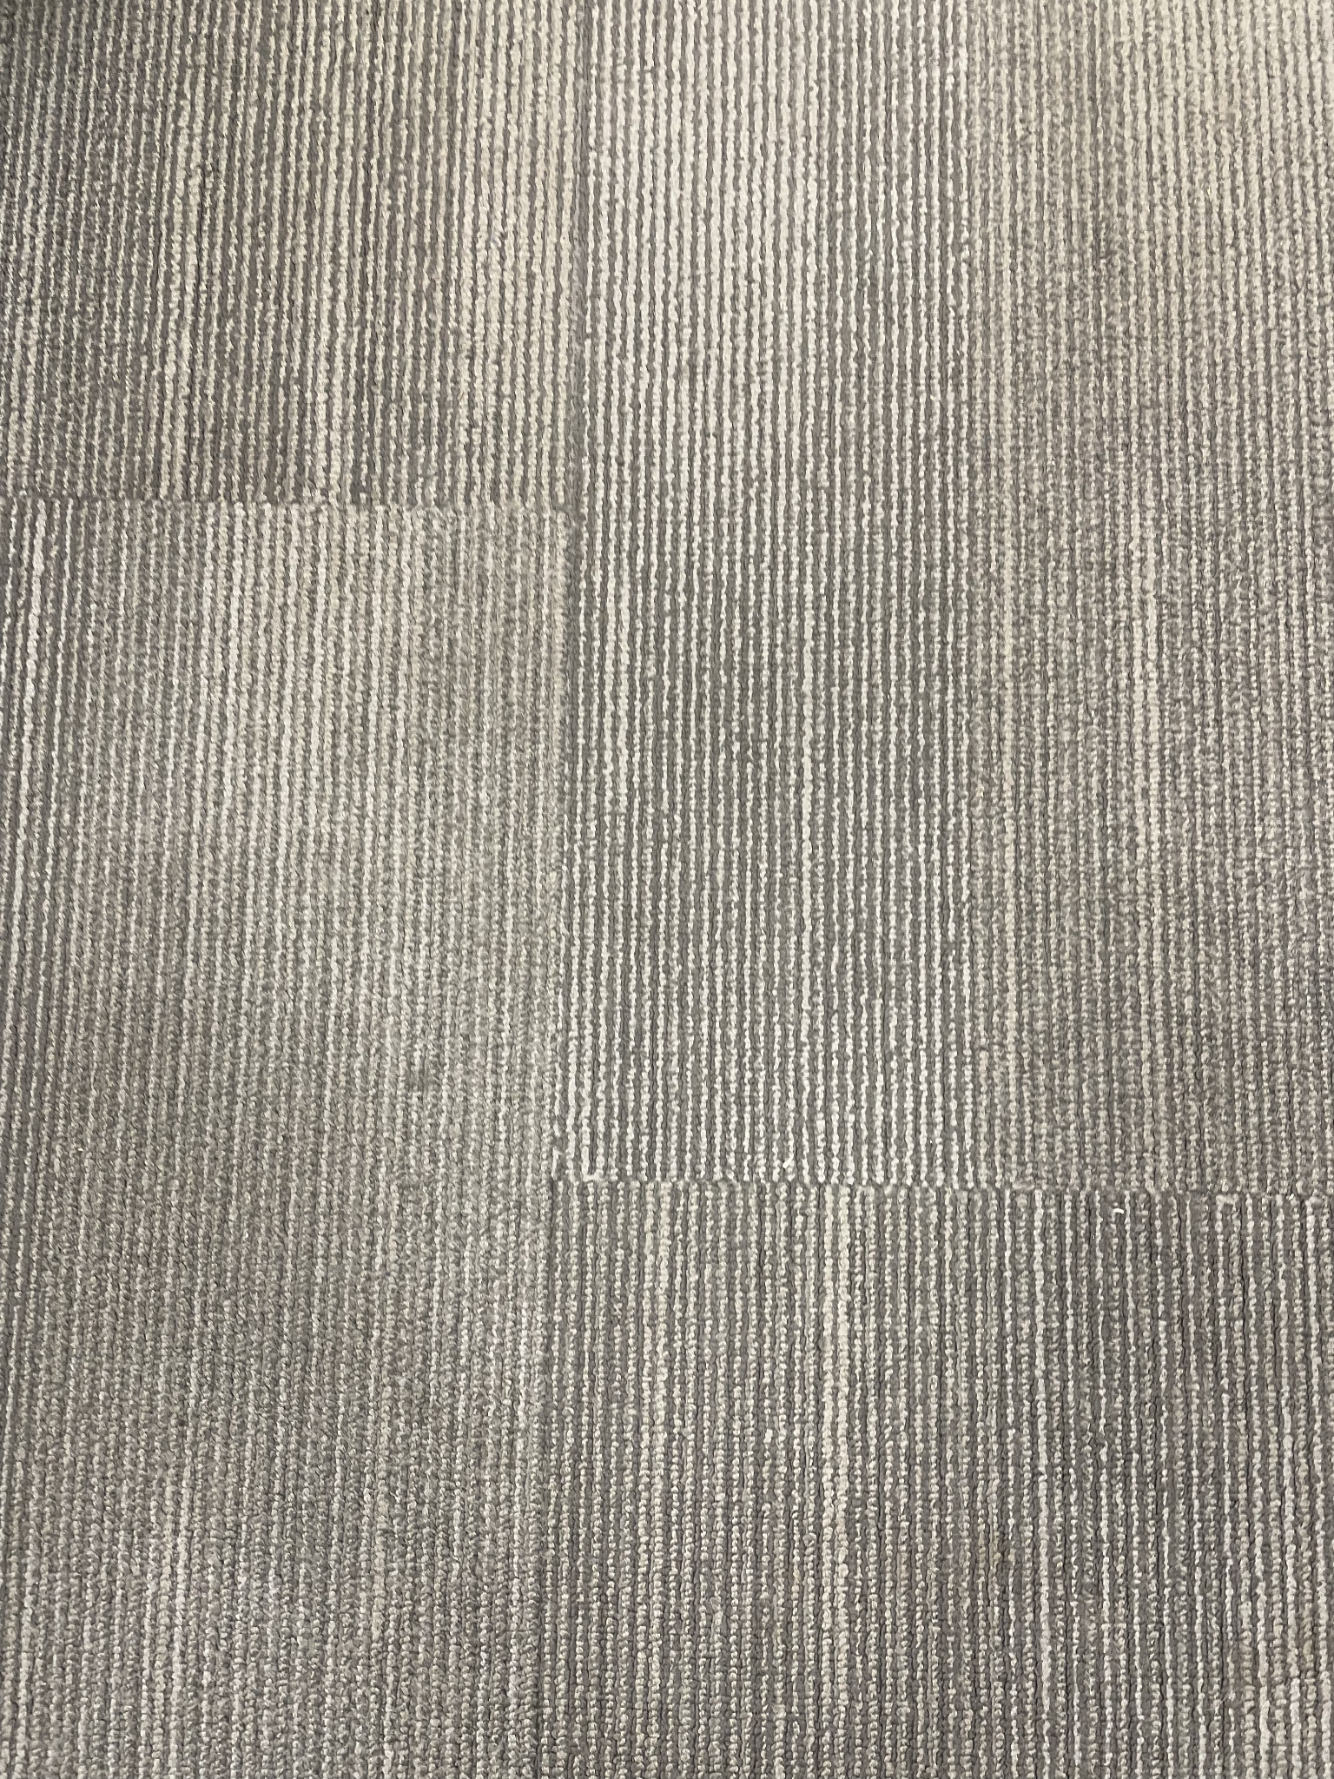

Figure 5. Edited Version of the carpet texture.

The fourth and last step was to add furniture and details like window sill and other things to make it look more detailed. On this step, I used the Unity Assets Store to use the existing furniture pieces to replicate furniture at the library. Here is the list of assets that I used for furniture and other pieces for the library.

* Apartment Kit By Brick Project Studio
* Patio Sofa Set By Ivan Loginov
* School Globe By Viverna
* School Assets by A.R.S|T.

## Programming

For the coding part of the project, I modified shader in order to make some funitures like desks and chair more vibrant in color. I have attached the shader code in the Codes in the assignment.

## Finished Product

The finished product was a bit underwhelming, compared to what I Imagined as the beginning of the project. I used the pictures that I took at the beginning of the project as a comparison to see if the project accomplished what I wanted to accomplish, which is to make the 3-D modeling look somewhat realistic using lighting and textures. Figure 6 is a screen shot from the model which can be used to compare it with Figure 2.

Figure 7 can be compared to Figure 3.

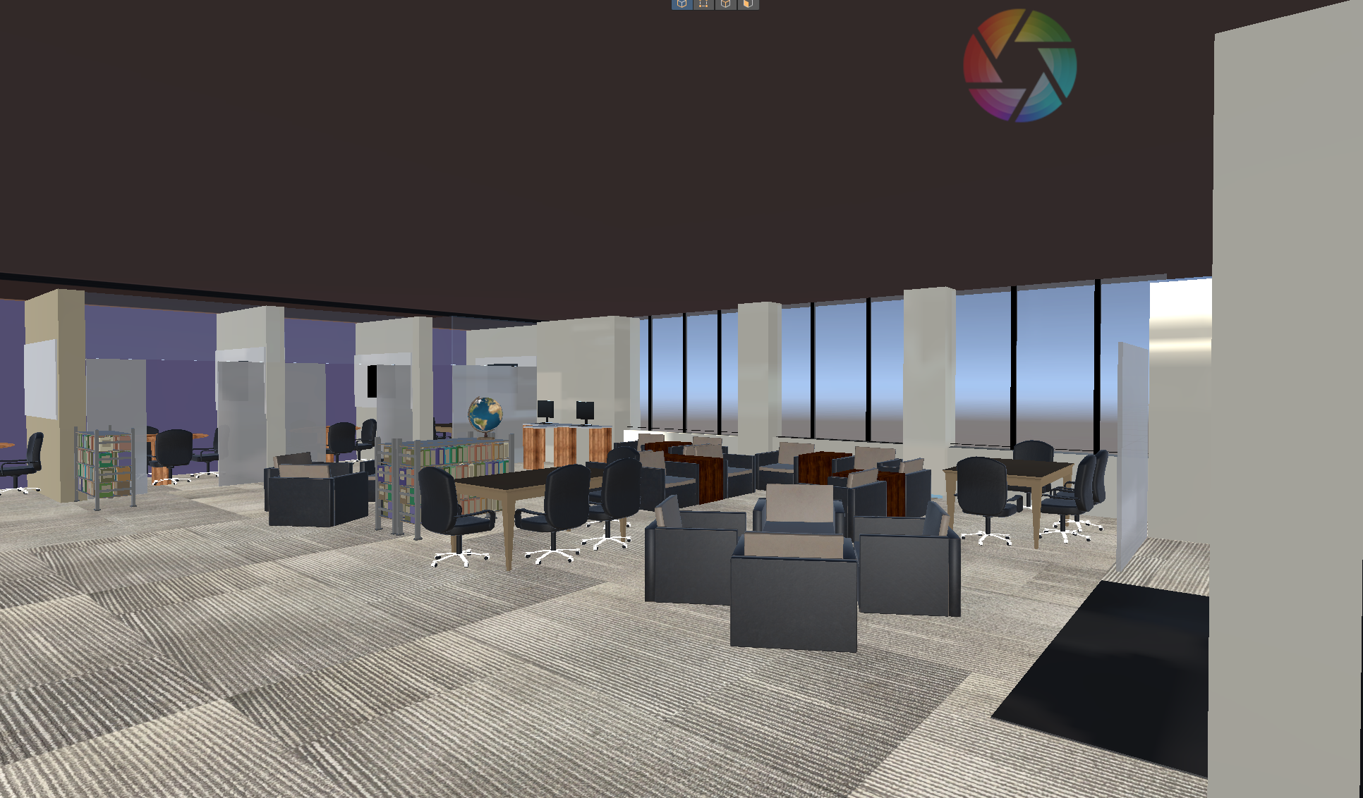

Figure 6. Modeling Picure same angle as Figure 2.

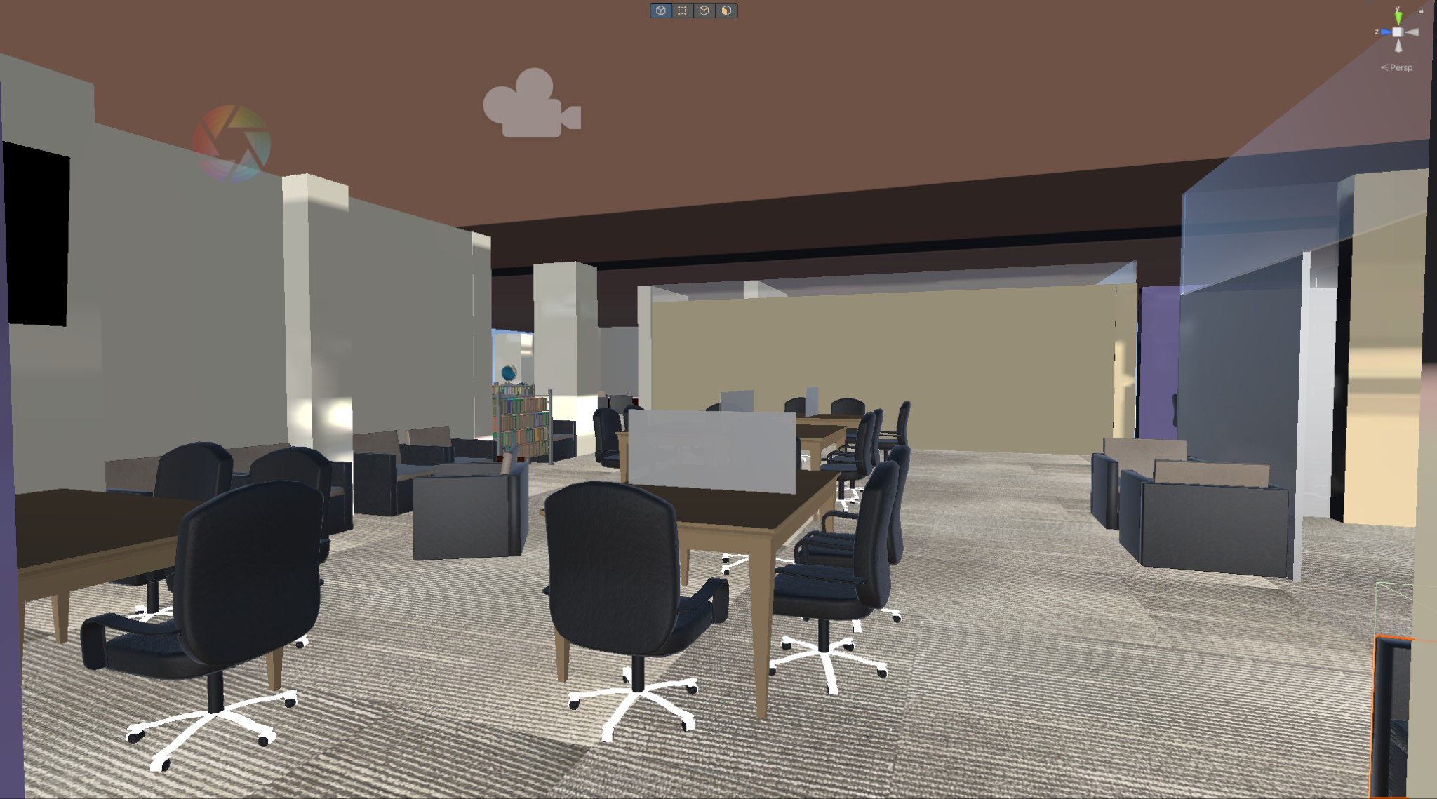

Figure 7. Modeling Picture same angle as Figure 3.

## Improvements

## Lighting

While I was able to produce good results with 3-D modeling, I was not able to implmenent the lighting that I was looking for. The model looks somewhat dull and does not look very realistic from the lighting aspect. To improve this, I need to look into more shader in order to make the lighting more realistic.

## Texture

Texture is another huge part that I could use some improvement on. The only textures that I was able to do myself was the carpet floor and the wooden finish on the computer table in the corner. The time was very limited considering how long it took for me to figure out how to remove shadows from the picture using GIMP. Given more time, I would’ve spent more time making more textures from pictures, for example the wall texture. Some of the reasons that the 3-D modeling looks dull is the fact that I could not make my own texture for the wall using the existoing pictures, but instead, I used a material that I created in Unity to save some time.

## Furniture Pieces

In this project, I mainly used furniture that I found from the Unity Assets store in order to replicate the library furniture, which caused some parts of the library to look somewhat off compared to the actual library. Only furniture that I was able to make on my was the Table that can be seen in the back and the computer desk in Figure 8 and the wood table between the walls in Figure 9. If I had more time and experience in modeling, I would’ve spent more time trying to create my own furniture in order to make the library look more realistic compared to what I have now.

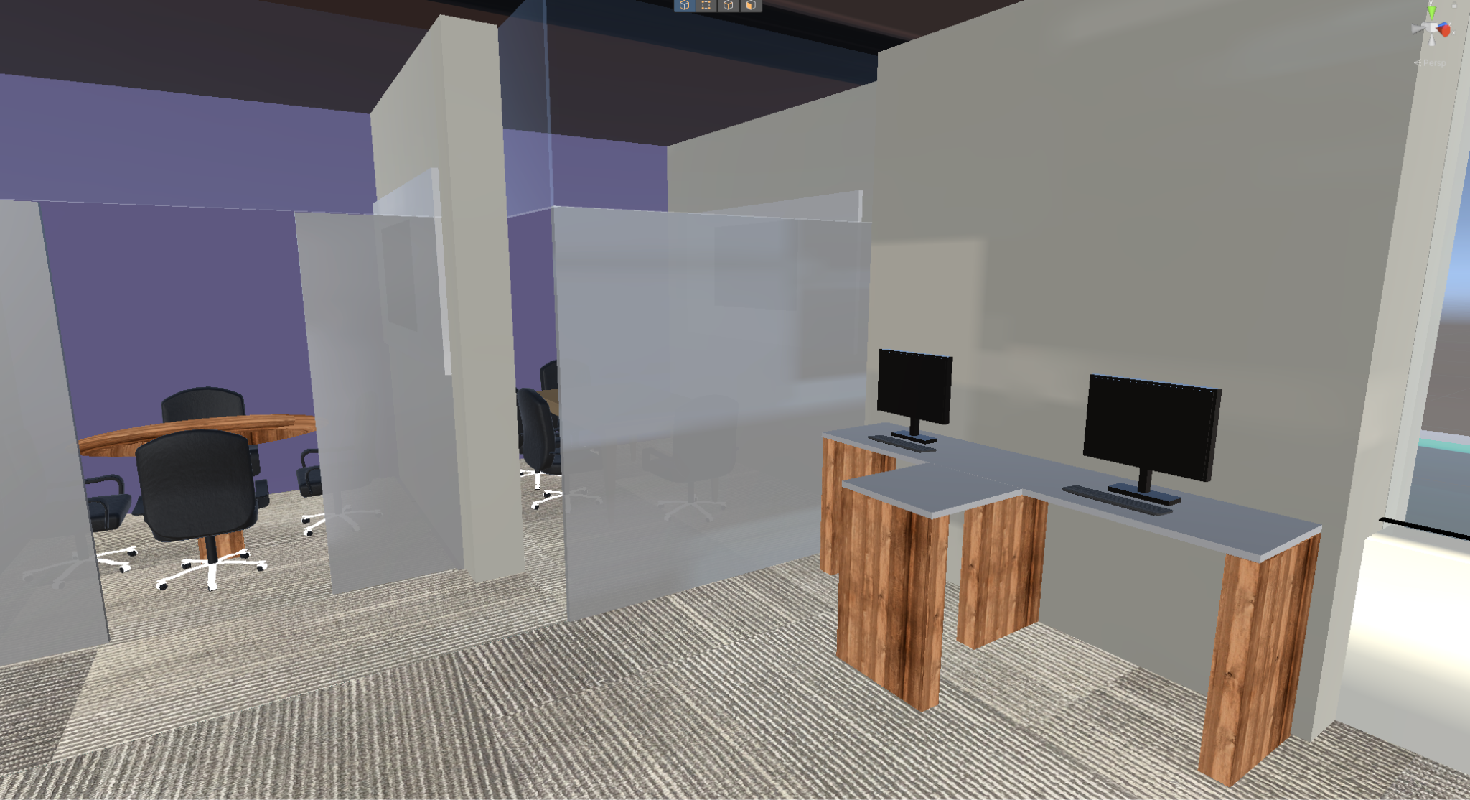

Figure 8. Furnitures created by me

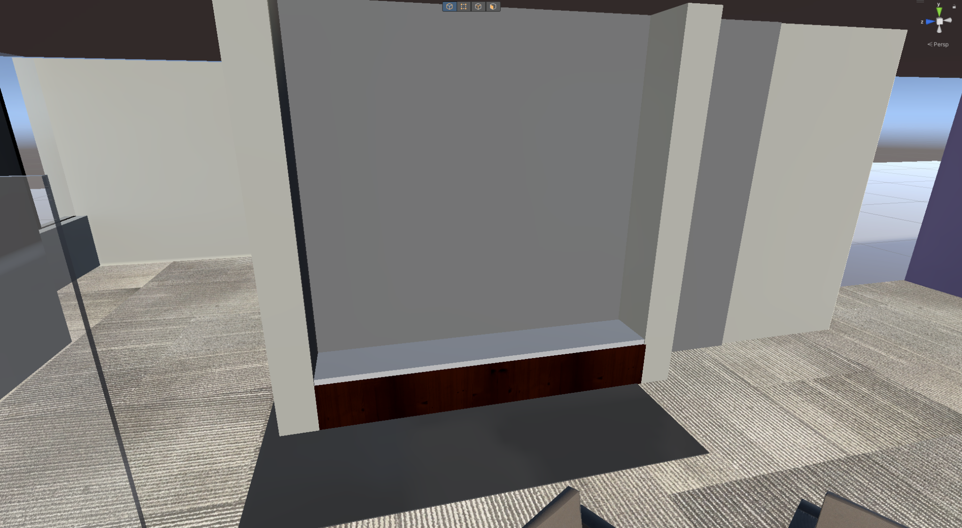

Figure 9. Wooden table between walls created by me

## Citation

Trotter Hall Floor Plan:

University, K. S. (n.d.). *Information Technology Services*. Login - Sign in | Kansas State University. <https://www.k-state.edu/facilities/projects/space/inventory/floor_plans/index.html>

ProBuilder Tutorial:

YouTube. (2022, January 11). *Unity Probuilder house building #1 in real-time*. YouTube. <https://www.youtube.com/watch?v=ElNfaUFpqmc&list=PLuVz-FGt23yLxDo1bjaFoslJoS3Ds5Iw_>

GIMP Remove Shadow Tutorial:

*Remove shadows in source images*. Remove Shadows in Source Images - The DarkMod Wiki. (n.d.). <https://wiki.thedarkmod.com/index.php?title=Remove_Shadows_in_Source_Images>

Apartment Kit By Brick Studio Project:

*Apartment kit: 3D environments*. Unity Asset Store. (n.d.). https://assetstore.unity.com/packages/3d/environments/apartment-kit-124055

Patio Sofa Set By Ivan Loginov:

*Patio Sofa Set: 3D furniture*. Unity Asset Store. (n.d.-b). <https://assetstore.unity.com/packages/3d/props/furniture/patio-sofa-set-227952>

School Globe By Viverna:

*School Globe: 3D interior*. Unity Asset Store. (n.d.-c). <https://assetstore.unity.com/packages/3d/props/interior/school-globe-152072>

School Assets by A.R.S|T.:

*School assets: 3D environments*. Unity Asset Store. (n.d.-c). <https://assetstore.unity.com/packages/3d/environments/school-assets-146253>